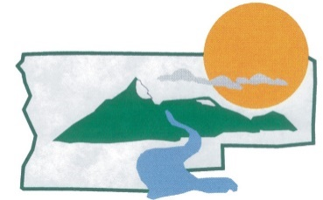

Public Works Department

PO Box 709  Madras, Oregon 97741  Phone: (541) 475-4459  FAX: (541) 475-1877

NEWS – FOR IMMEDIATE RELEASE
March 23, 2020

Jefferson County Awarded $25,000 to assist landowners in treating noxious weeds

For More Information:
Thomas Laird
Thomas.laird@co.jefferson.or.us
Public Works: 541-475-4459

Salem – In late February, the Oregon State Weed Board awarded $25,000 to the Jefferson County Weed Control for treating noxious weeds in the Trout Creek watershed and Gateway area for 2020.

The award was one of 58 grants totaling $1,635,486 for the ODA Weed Grants ($1,416,509 for ODA Noxious Weed Grants, $218,977 for ODA County Noxious Weed Grants) recommended for approval in Cycle 33-2020 provided to local organizations statewide to support fish and wildlife habitat and water quality projects. The grants represent great natural resource enhancement projects occurring throughout all areas around the state.

“Our project goal is improving riparian and upland habitat, mostly on private lands, by reducing noxious weeds such as Scotch thistle, Whitetop, Yellow star thistle and others. Treating weeds improves establishment of perennial grasses and riparian vegetation, benefitting streamflow for aquatic species and provides added forage for wildlife or livestock grazing,” says Thomas Laird, Weeds Program Coordinator with the County.

The Trout Creek County Weed Grant targets County class-A noxious weeds in the Trout Creek and Mud Springs watersheds, from Ashwood to Gateway, with the project expected to begin in April and be completed by the end of the year. Landowners are encouraged to reference the Public Works Department on the Jefferson County website for information on noxious weeds in the County.

Funding for grants comes from partnership with OWEB- Oregon Lottery funds. Since 1999, the Oregon Lottery has provided over $500 million to OWEB’s grant program that helps restore, maintain and enhance Oregon’s watersheds. Combined, the Lottery has earned over $9 billion for watershed enhancements, public education, state parks and economic development. For more information about the Oregon Lottery visit www.oregonlottery.org.

For additional information about this project contact Thomas Laird at thomas.laird@co.jefferson.or.us. For additional information about ODA Noxious Weed Grant Programs, contact Tristen Berg at tberg@oda.state.or.us.

